

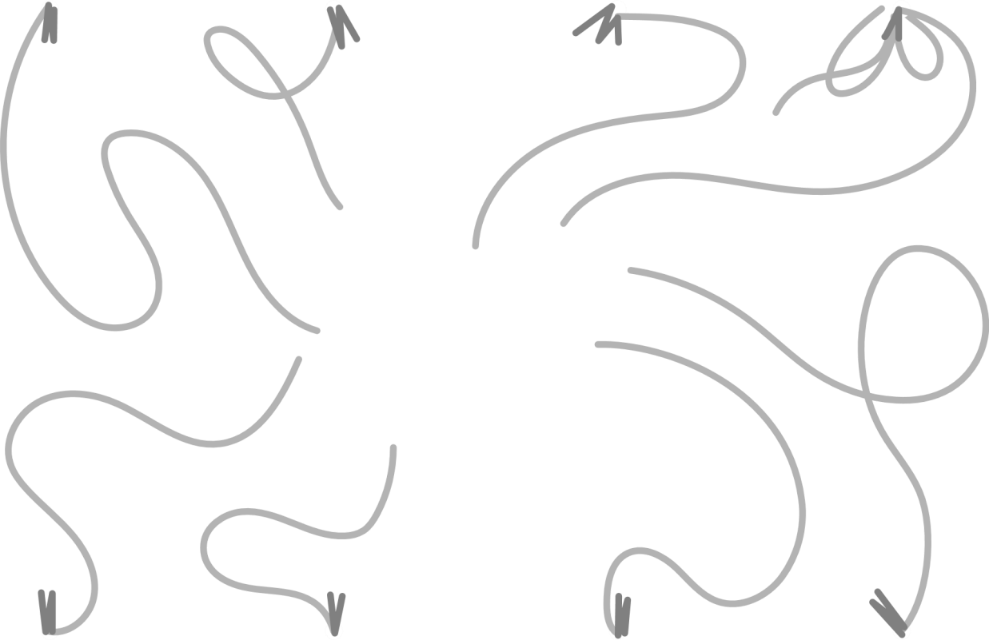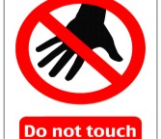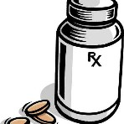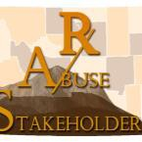

**Keep Meds Safe**

Keep medication somewhere where children can’t reach them, like a high cabinet or in a locked cabinet or safe.

**OUT OF**

**REACH**

At home talk with your children about keeping medicines in safe places and not taking medicine without an adult giving it.

**HOME EDUCATION**

Never leave pill bottles or pills on a counter top, table or bedside table where children can reach them.

At home or while traveling, keep medicines in their original, child resistant containers.

**NO EASY ACCESS**

**KEEP IN BOTTLES**

**YOUR CHILD’s**

**SAFETY**

More information can be found at Up and Away:

**https://upandaway.org/**

**TEACH SAFETY**

Teach your child about medication safety and when it’s appropriate to take medication.

**LEARN MORE**

More can be found at: **https://www.wyrxabusest akeholders.com**/

**PHONE**

Save the Poison Help Line in your phones & give it to grandparents & others who care for your child.

**EMERGENCY**

The Poison Help Line number is: **1-800-222-1222**. Don’t forget, you can always call **911**.