What is Fentanyl
Fentanyl is a potent synthetic opioid drug approved by the Food and Drug Administration for use as an analgesic (pain relief) and anesthetic. It is approximately 100 times more potent than morphine and 50 times more potent than heroin as an analgesic.

WHAT IS ITS ORIGIN?
Fentanyl was first developed in 1959 and introduced in the 1960s as an intravenous anesthetic. It is legally manufactured and distributed in the United States.

Fentanyl is a Schedule II narcotic under the United States Controlled Substances Act of 1970.
Digital Dealers
“THE DRUG DEALER ISN’T JUST STANDING ON A STREET CORNER ANYMORE. IT’S SITTING IN A POCKET ON YOUR PHONE." *
They have turned our smartphones into a one-stop shop to market, to sell, and to deliver deadly drugs. Criminal drug traffickers are using mainstream social media apps. Criminal drug networks are now front and center on social media, with us whenever our smartphones are.

Fast Facts On Fentanyl
Just 2 milligrams of fentanyl can be lethal, equivalent in size to a few grains of salt.
According to a report from the National Institutes of Health, law enforcement across the country seized nearly 10 million counterfeit pills laced with fentanyl in 2021. A 50-fold increase in just 3 years.
Drug cartels have chosen to use social media to expand their business for several reasons: it’s widely accessible, it’s easy to use, drug traffickers can hide their identities, they can lie about what they are selling, and most importantly, the sites permit the sale of counterfeit pills every day to go unchecked.
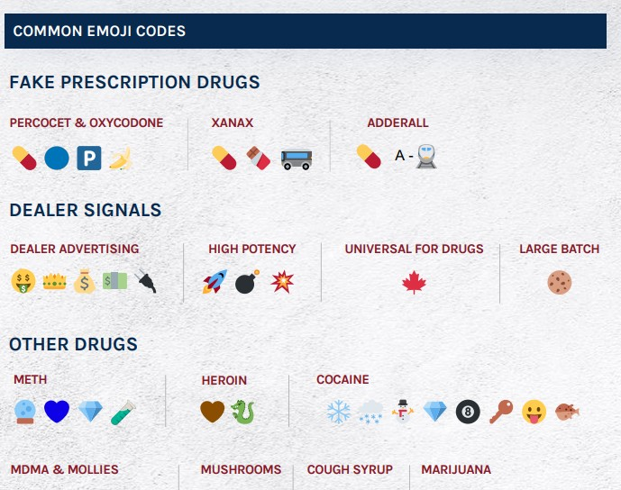
These criminal drug networks are misrepresenting what they are selling. People think that they are buying real Xanax pills, real Adderall pills, real Oxycodone pills, using online platforms they trust, when in fact they are getting fentanyl, in pills that look just like the real thing.
Criminal drug networks are mass- producing fake pills and selling them online as legitimate prescription pills. Fake prescription pills are easily accessible and often sold on social media and e-commerce platforms, making them available to anyone with a smartphone, including minors.
Known emoji’s and code words are being widely used as signals online, in the online buying and selling of deadly drugs like fentanyl and fentanyl-laced fake pills.
Emoji Drug Codes
US Drug Enforcement Administration

DEA lab testing reveals that 4 out of every 10 pills with fentanyl contain a potentially lethal dose.
Counterfeit pills have been identified in all 50 states. DEA and its law enforcement partners are seizing deadly fake pills at record rates.
Counterfeit pills have been identified in all 50 states and the District of Columbia.
The DEA seized enough Fentanyl in 2021 to provide a lethal dose to every American.

Sources:

www.getsmartaboutdrugs.gov/
https//www.nida.nih.gov/publications/drugfacts/fentanyl
www.dea.gov/onepill
*Anne Milgram, administrator of the Drug Enforcement Administration 12/16/21 press conference via The Washington Post
https://www.dea.gov/press-releases/2021/12/16/dea-reveals-criminal-drug-networks-are-flooding-us-deadly-fentanyl

