Drug Use & Abuse in Teens

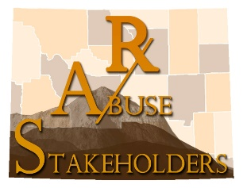

https://opa.hhs.gov/adolescent-health/substance-use-adolescence

